Kathryn Atherton

ABE 20100 – Dr. Mosier

Honors Project

Modern Meadow, Inc.

Modern Meadow, Inc. was founded in 2011 by Andras Forgacs to use biofabrication in order to create leather identical to traditional leather. The company claims that its process is more environmentally friendly and efficient than that of today’s typical leather trade, as only the amount of leather needed is produced and harsh chemicals to remove hair and flesh from the skin of the animal are not used, as none is produced. Finally, since the product does not use the skin of slaughtered animals, the product appeals to socially-conscious individuals who oppose animal cruelty, as well as environmentally-conscious individuals who recognize the large amounts of water, land, feed, and fuels required to raise animals in order to produce leather. As this process is fairly new, not much information is known about the exact of various steps in the process; thus, throughout this paper, the exact amounts of materials and energy entering and leaving the process are based on informed guesses, knowing the basic steps of the process. Inefficiencies due to assumptions made will not be commented upon.

Modern Meadow, Inc. begins by obtaining about 1,000 cells to culture from a live animal, species depending on the desired pattern of leather. This culture, contained in a test tube with one milliliter of water, is composed of a variety of cells, including epithelial cells, fibroblasts, and keratinocytes, among other types of cells used to produce the collagen that makes up the final product. These cells are engineered to produce the pattern of collagen desired by using restriction enzyme and sections of DNA base pairs in order to insert the genetic code for the leather into the epithelial cells. The cell-to-restriction enzyme-to-DNA pattern ratio is 1:3:3, to ensure that all the cells receive the gene to produce the correct collagen. The solution is allowed to sit at room temperature for about six hours to allow the reaction to occur; the thermal energy at this temperature gives the reaction the energy it needs to degrade the DNA and then repair it. Along with the cellular waste, all 3,000 of the restriction enzymes and 2,000 sets of the DNA base pairs come out of this step. It is assumed that for the enzymes and DNA base pairs, one-half of the materials that exit this step are recycled back into the next batch and the other half is purged. One thousand cells engineered to produce the desired collagen exit this unit operation.

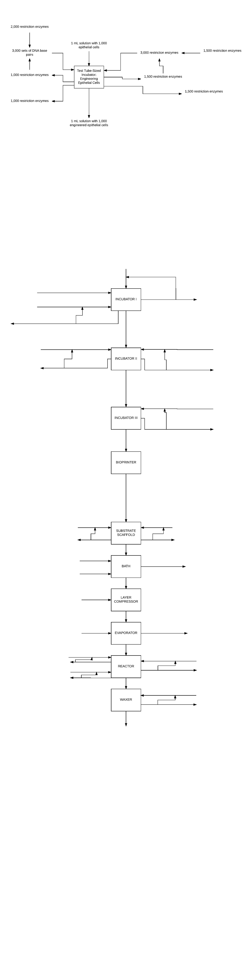

*Figure 1: Engineering Epithelial Cells Unit Operation Process*

The next step involves scaling up the number of cells from one thousand to five million. This is done by moving the engineered cells from the test tube to a standard petri dish, adding 0.1 microliters of nutrients, including oxygen, agarose, antibiotics, and water, and 0.01 microliters of additives, including growth factors, minerals, fiber, fatty acids, and amino acids, to the petri dish and allowing the cells to multiply until the cell number reaches 25,000. As a eukaryotic cell culture doubles its population every twenty-four hours, this process takes six days. 0.052 of a microliter of the nutrients and 0.0052 of a microliter of additives are unused. It is assumed that half of each of these volumes is recycled back to the next batch and the other half is purged, along with the cellular waste. After the cell culture out-grows the petri dish, the cells are moved to a dinner plate-sized container, along with 20 microliters of nutrients, the same as those previously described, and two microliters of additives, also the same as those previously described. The cells are left to multiply until the count reaches 5,000,000, which takes another nine days, after which 10.05 hundredths microliters of nutrients and 1.005 thousandths microliters of additives exit the unit operation, as they are unused. Again, it is assumed that half of each of these volumes is recycled back to the next batch and the other half is purged along with the cellular waste.

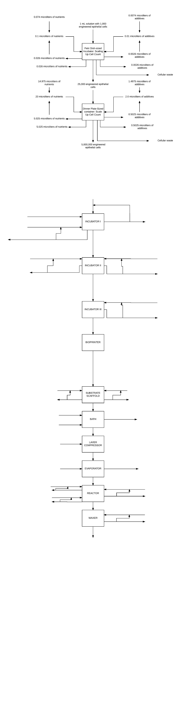

*Figure 2: Scaling Up Cell Count Unit Operation Process*

The 5,000,000 engineered cells produced thus far are transferred to a bioprinter. The bioprinter ejects the cells uniformly onto a substrate scaffold of dimensions three feet by six feet. 400 liters of the previously stated nutrients and 40 liters of the previously stated additives are added to the substrate scaffold so as to allow the cells to continue to multiply and produce collagen until the number reaches 100,000,000,000,000, creating a layer of collagen of dimensions three feet by six feet by one inch. This process takes 25 days. Two hundred liters of nutrients and 20 liters of additives are unused; half of each of the volumes of unused materials are recycled to the next batch while the other half, as well as the cellular waste, is purged.

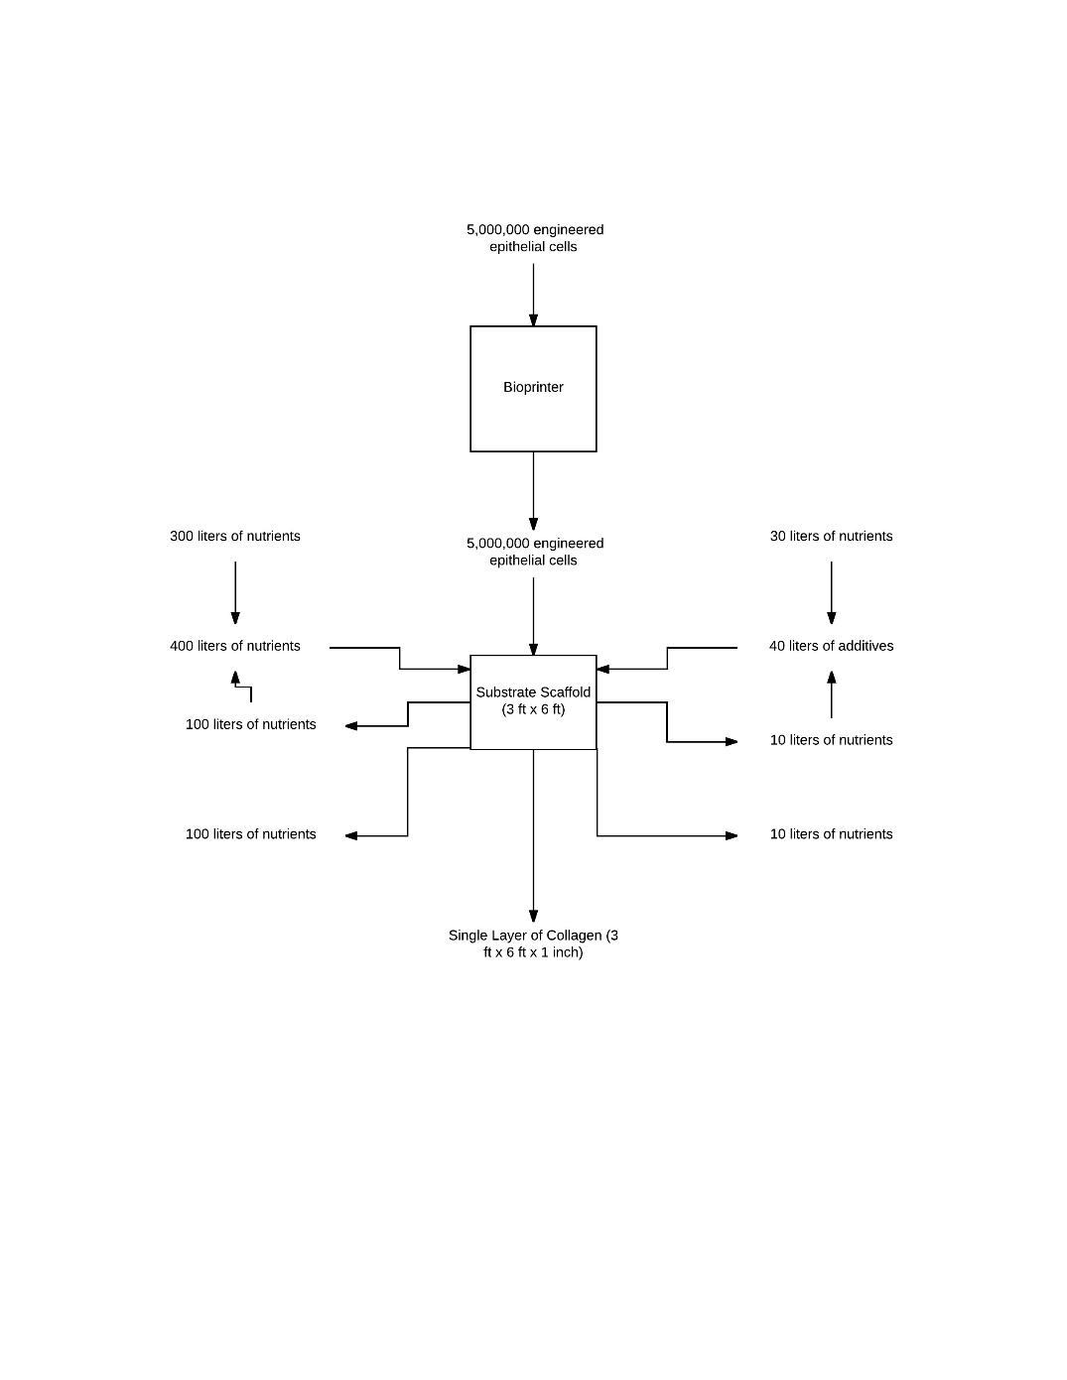

*Figure 3: Producing Singular Collagen Layer Unit Operation Process*

The produced layer of collagen is next washed. Sixty liters of cold water and five liters of soap are used to clean the collagen of any residue from the nutrients, additives, and substrate scaffold. After this unit operation, which takes one hour, 65 liters of dirty, soapy water and a clean singular layer of collagen are produced. The water is purged while the layer of collagen is added to a layer compressor. The layer compressor allows twenty layers of collagen to fuse together, forming one consistent layer of dimensions three feet by six feet by one and two thirds feet.

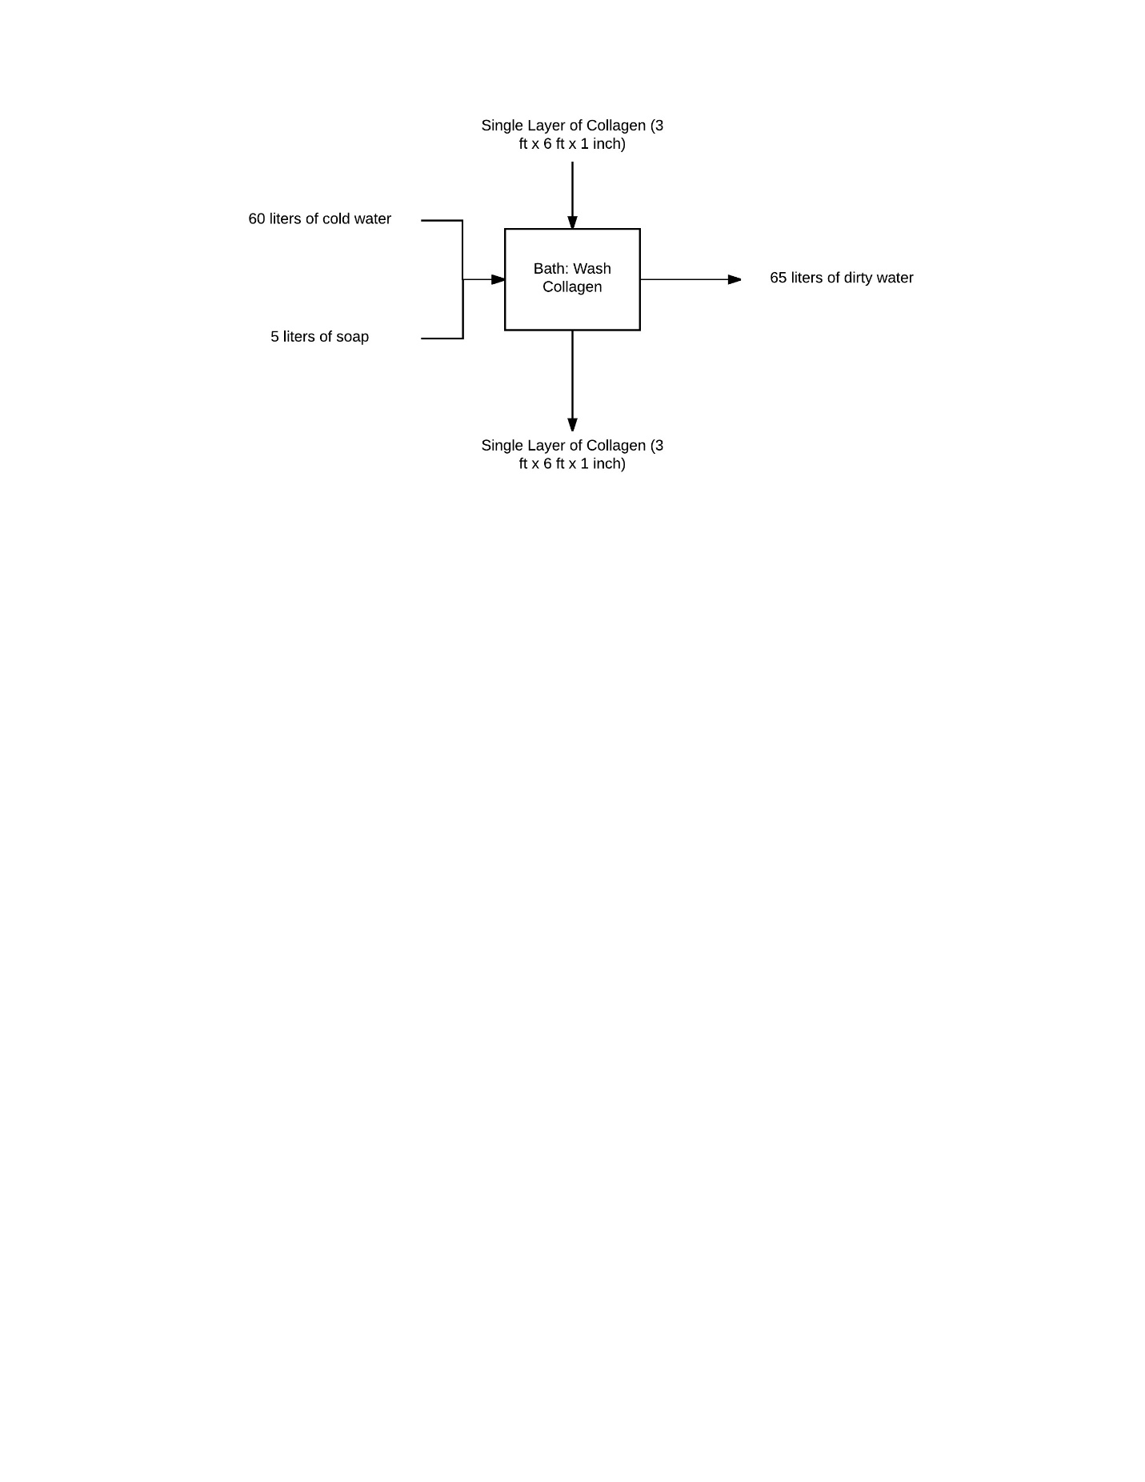

*Figure 4: Washing Collagen Unit Operation Process*

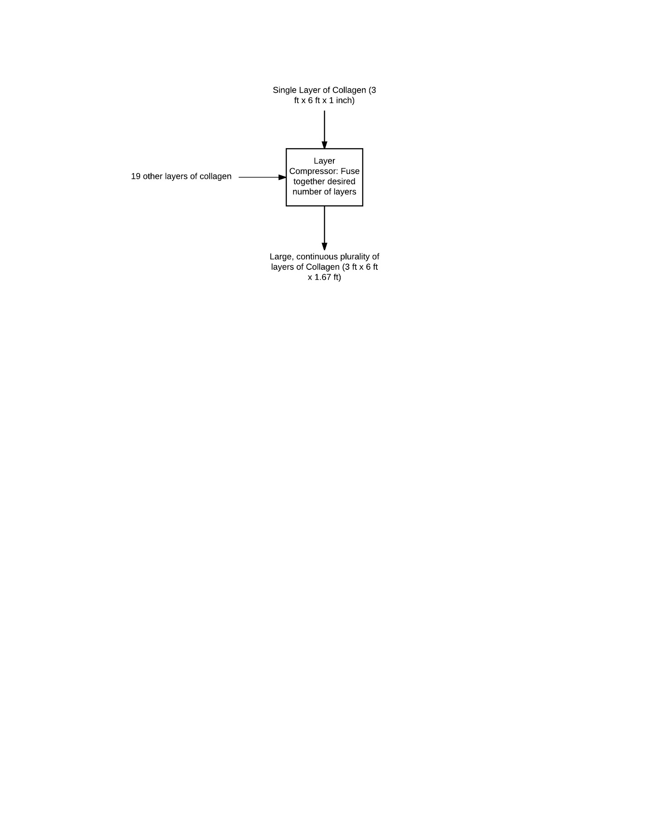

*Figure 5: Fusing Multiple Collagen Layers Together Unit Operation Process*

The large, single layer is then placed in a dryer. The collagen begins with a temperature of 20 degrees Celsius. According to the Science in Society Archive, collagen in its natural state has 1.62 kilograms of water per kilogram of protein, and according to a formula found in a paper by Harvard University researchers entitled “Using elemental ratios to predict the density of organic material composed of carbon, hydrogen, and oxygen”, the density of collagen is 1052 kilograms per cubic meter. As there are 0.851 cubic meters of collagen to be dried, there are 895 kilograms of collagen; 342 kilograms of this mass are actual protein, while the other 553 kilograms are water to be removed. In producing leather, all of the water content must be removed in order to prevent bacteria from growing and degrading the product in the future. Thus, the dryer must remove all 553 kilograms of water. It is assumed that 18 cubic meters (at standard temperature and pressure) of dry air enters the dryer per minute, which is 3.6 kilograms of air every minute. It is assumed that the air enters with a dry bulb temperature of 100 degrees Celsius and does not contain any moisture. Its enthalpy is 104 kilojoules per kilogram of dry air. According to Joseph R. Kanagay’s research paper “Specific Heats of Collagen and Leather”, untreated collagen has a heat capacity of 1557.7 kilojoules per kilogram-degree Celsius; as there are 342 kilograms of collagen, the collagen must absorb 532,000 kilojoules of energy in order to raise its temperature one degree Celsius. Assuming the air leaves with a temperature of 30 degrees Celsius and is completely saturated, the exiting air contains 0.028 kilograms of air per kilogram of dry air and has an enthalpy of 100 kilojoules per kilogram of dry air. As there are 3.6 kilograms of dry air entering and leaving every minute, 0.10 kilograms of water leaves every minute and the air loses 14 kilojoules of energy every minute. With these specifics, the drying process takes just under four days to complete and the collagen absorbs 79,000 kilojoules of energy from the air. This equates to a temperature increase of 0.15 degrees Celsius. As this change is so small, it is assumed that no cooling process is needed. At the end of the drying process, the products are a dry collagen layer that has a volume of 0.32 cubic meters and a temperature of 20.15 degrees Celsius and, in total, 20,000 kilograms of dry air containing 553 kilograms of water.

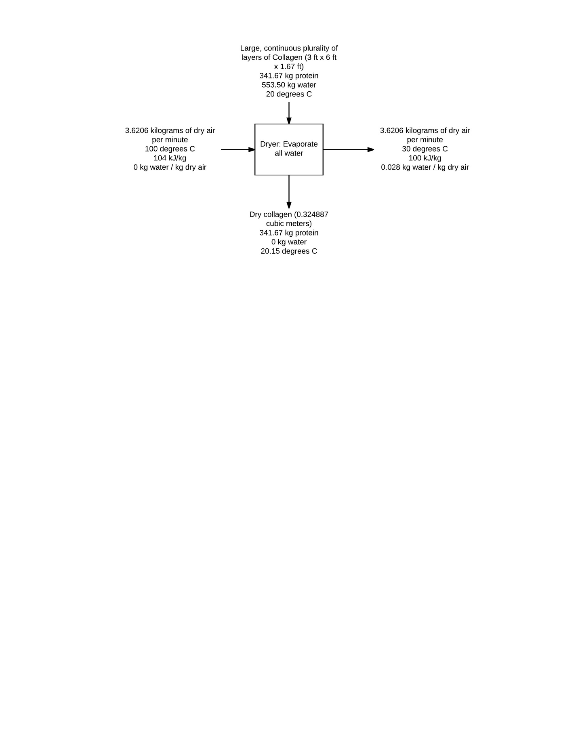

*Figure 6: Evaporating Water from Collagen Unit Operation Process*

Once the water is removed from the collagen, the material is tanned using 400 liters of chromium (III) sulfate, 400 liters of additives in order to add color and odor to the leather, and 400 liters of preservatives including calcium propionate, sodium nitrate, and sulfites. The tanning process chemically processes the skin to prevent its decay. The chromium forms polynuclear complexes, as shown in the process seen in Figure 7. These complexes bridge the gaps between collagen chains to maintain the stability of the organic material. After the tanning is complete, the leather enters the next step, while 75.1 liters of chromium (III) sulfate, 75.1 liters of additives, and 75.1 liters of preservatives that went unused exit the unit process. Again, it is assumed that half of the unused materials are recycled back into the next batch while the other half is purged.

punodtu03 Oxo 
"OZH 
pundu•os 0-10 
0001 
'les 

*Figure 7: Chromium (III) Sulfate reaction to form polynuclear complexes (Mann & McMillan)*

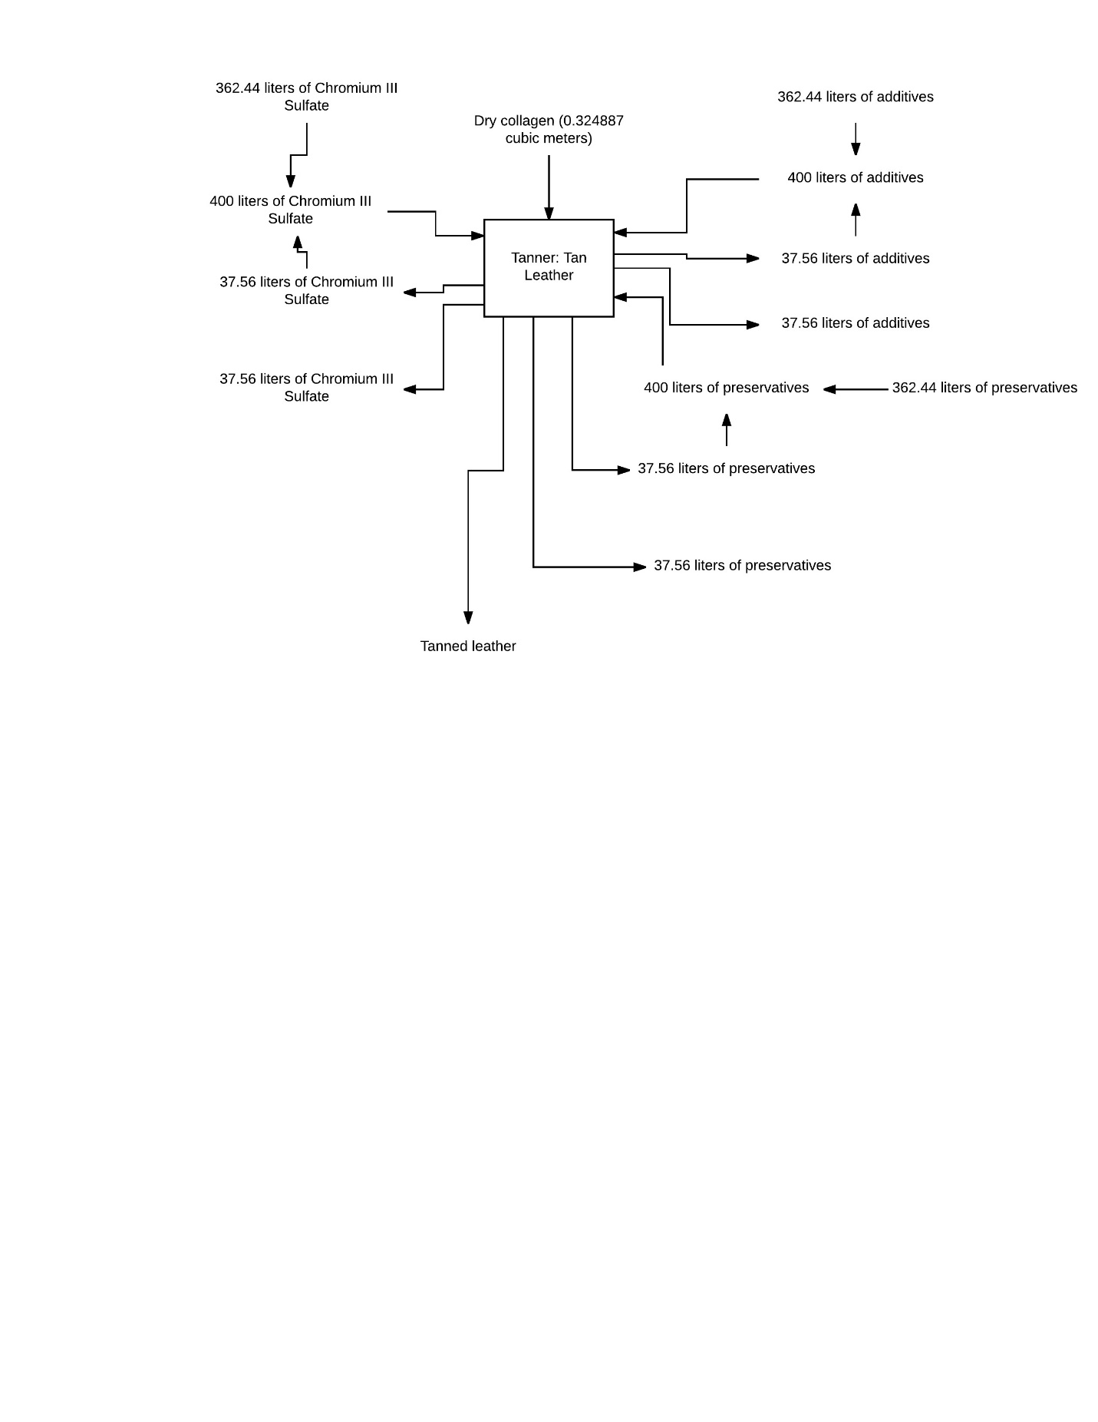

*Figure 8: Tanning Leather Unit Operation Process*

The next step in the process is to add a thin layer of wax to either side of the leather to preserve the final product from water damage. It is assumed that a one-millimeter layer of wax is added to each side of the leather and that the lateral surface area of the leather did not shrink during the drying; thus 1.67 liters, or 1.503 kilograms, of wax must be used to cover the entire piece of leather with wax. Two liters of wax enter the unit process at 54 degrees Celsius and are applied with a rolling cylinder. One-third of a liter of unused wax leaves the process. One-half of the unused wax is recycled back to the next batch while the other half is purged.

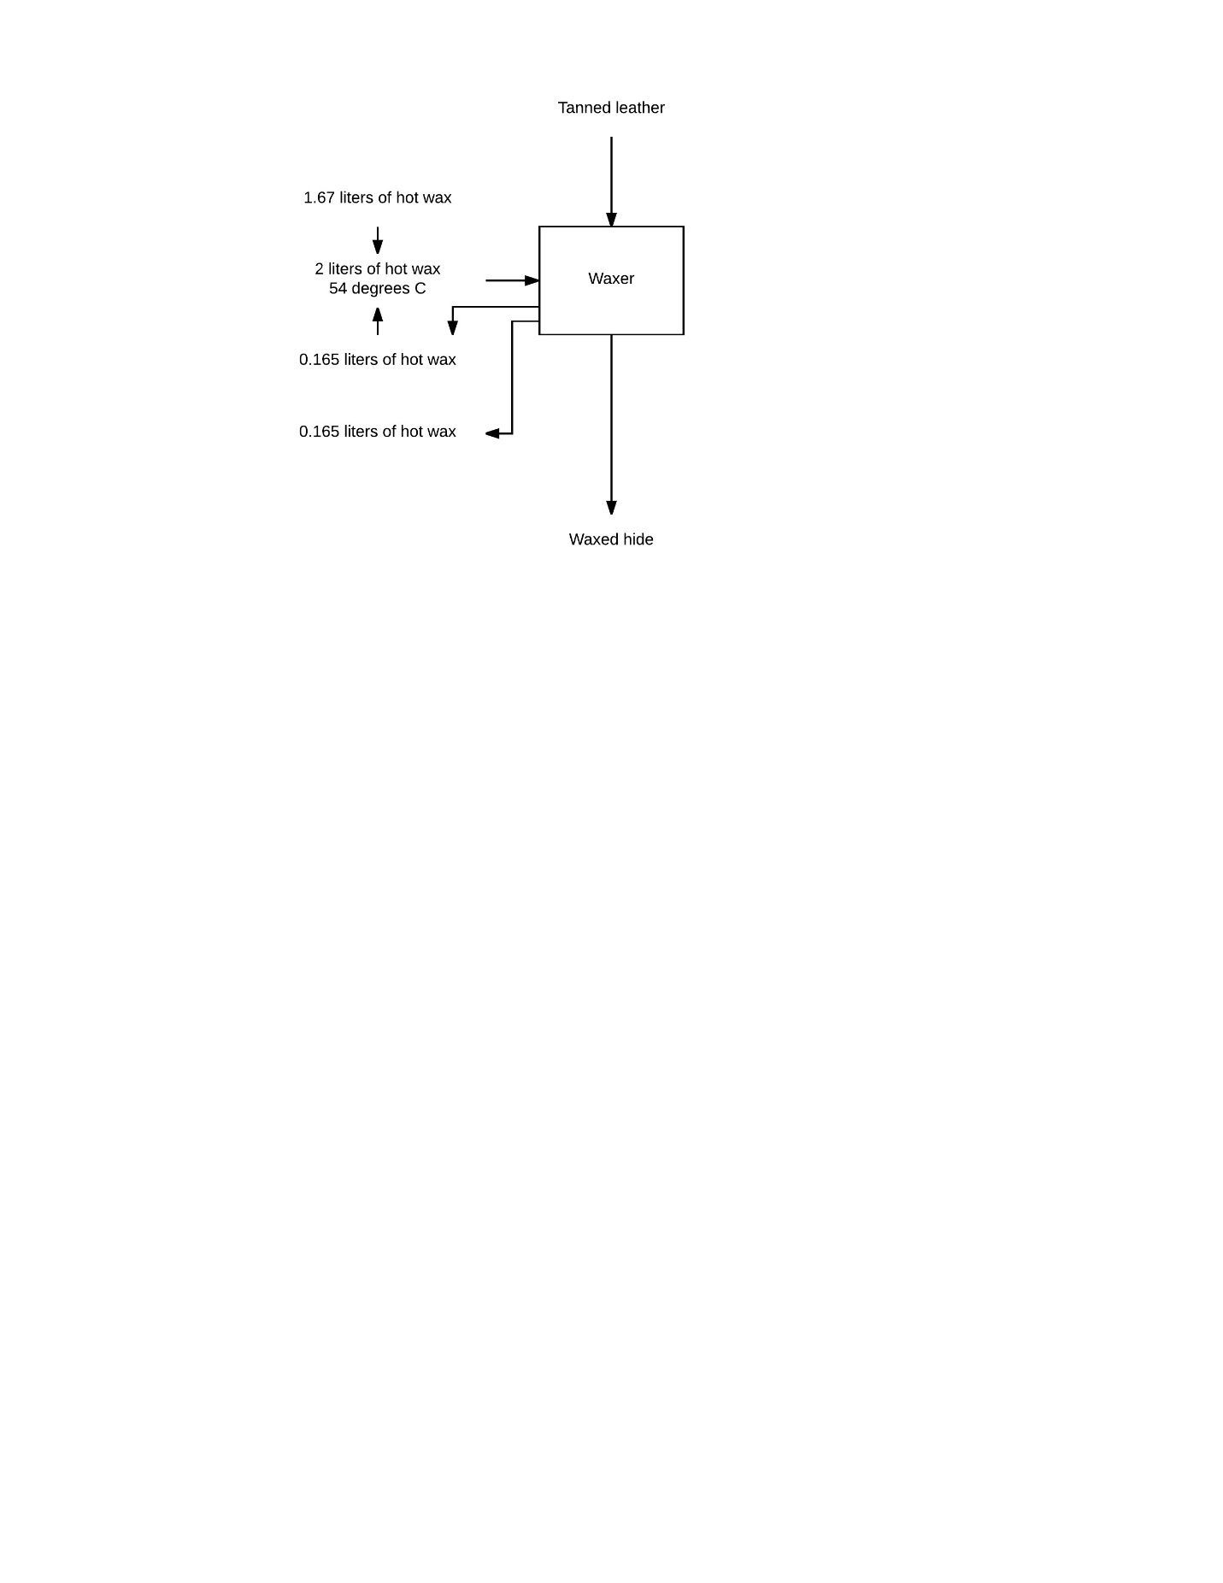

*Figure 9: Adding Wax Finish to Leather Unit Operation Process*

The waxed leather is then allowed to cool at room temperature. Assuming the air temperature entering the cooler is 20 degrees Celsius with an enthalpy of 20 kilojoules per kilogram and that of the air leaving the cooler is 25 degrees Celsius with an enthalpy of 25 kilojoules per kilogram, the air takes up 18 kilojoules per minute throughout the cooling process. The wax has a specific heat of 2.14 kilojoules per kilogram-degree Celsius; assuming the wax begins with a temperature of 54 degrees Celsius and ends with a temperature of 20 degrees Celsius, the wax must lose 109 kilojoules to the air. This cooling process takes six minutes. Leaving the cooler is 110 kilojoules of air and the final product: leather produced without the slaughter of animals.

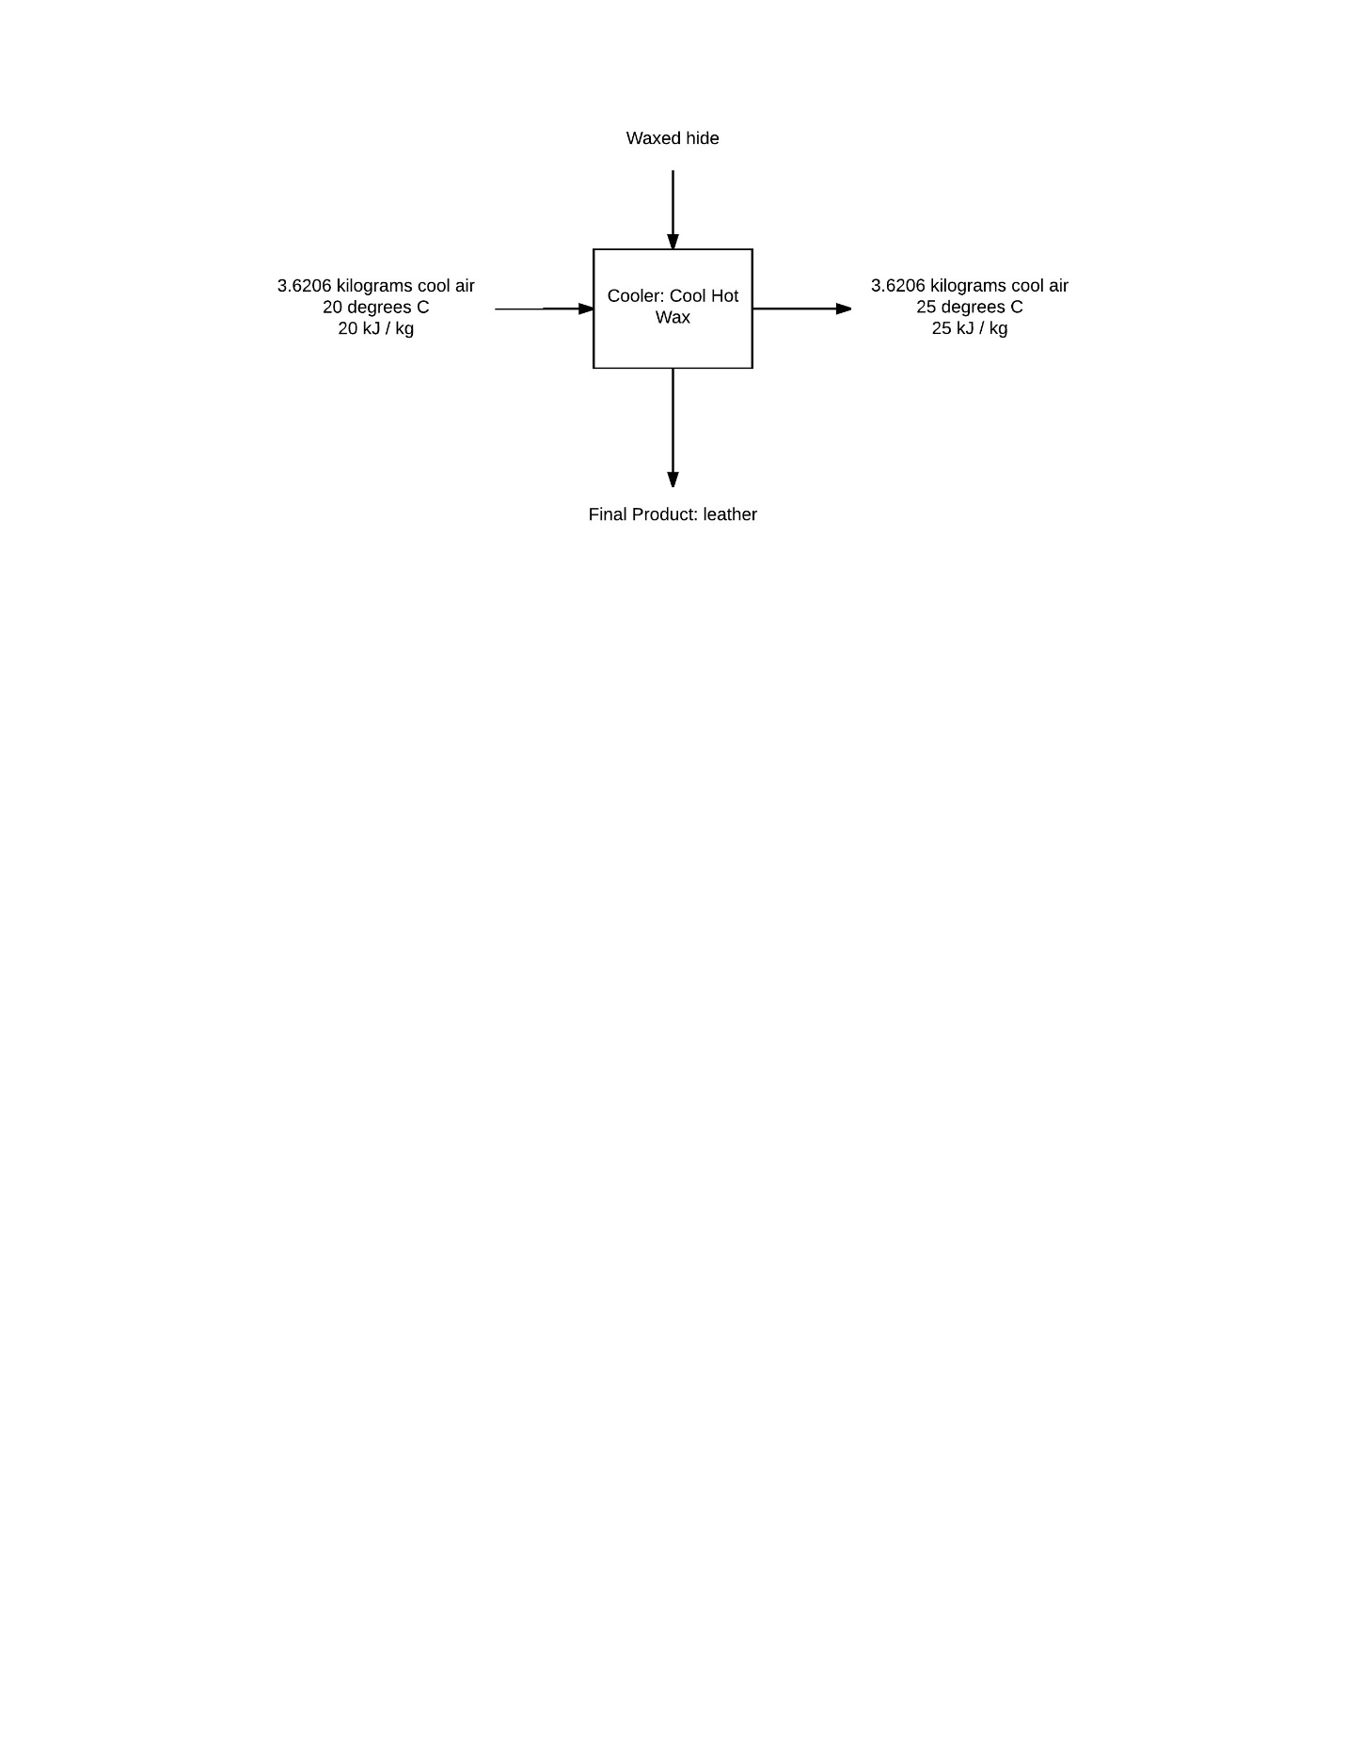

*Figure 10: Cooling Hot Wax Finish Unit Operation Process*

There is no question that this process is more efficient than that of the traditional leather industry. According to Collin Dunn in his article “Can Leather Be a Tree Hugger-Friendly Material?”, to raise a cow for its meat and hide requires eight acres of land for the cow, nearly 15,000 pounds of food, 1.2 million gallons of water, and 1.5 acres of land to grow the food for the cow, as well as other chemicals to ensure the health of the cow and its food. This process requires a fraction of that, and reduces waste of the hide as well as the use of harsh chemicals to prepare and preserve the hide of a natural cow. However, Modern Meadow, Inc.’s process is not perfect. One of the biggest inefficiencies of the process is the use of Eukaryotic cells. These cells double their population once every day, while bacteria such as *E. coli* can do the same in under half an hour, making the time to grow the desired amount of collagen much shorter. The company already engineers the animal cells to contain the desired type of collagen, so engineering bacterial cells would not be much different; in fact, it might be cheaper, as cultures of *E. coli* are commercially available for teachers to use in science classes. The company Carolina cells five milliliters of bacteria for just under $11 while the company Science Exchange sells mammalian cell cultures starting at $400 per sample. By using a different cell type altogether, Modern Meadow, Inc. could save time and money, as the collagen protein, not the cells themselves, is the final product. Other inefficiencies in the process are unknown at this time, as the exact details of the process’s use of materials and machinery are not public knowledge and cannot be commented upon.

**Bibliography**

Air Properties. (n.d.). Retrieved December 06, 2016, from http://www.engineeringtoolbox.com/air-properties-d_156.html

Croft, S. (1987). Kaye and Laby – Tables of Physical and Chemical Constants (15th edn). *Physics Bulletin,* *38*(4), 149-149. doi:10.1088/0031-9112/38/4/037

Dibenedetto, B. (2016, August 2). The Digital Source For Eco-fashion and Sustainable Living. Retrieved September 23, 2016, from http://magnifeco.com/material-matter-the-fashionable-future-of-leather-cruelty-free/news/

Dunn, C. (2007, February 14). Can Leather Be a TreeHugger-Friendly Material? Retrieved December 06, 2016, from http://www.treehugger.com/green-architecture/can-leather-be-a-treehugger-friendly-material.html

Escherichia coli, Living, K-12 Strain, Tube. (n.d.). Retrieved December 06, 2016, from http://www.carolina.com/bacteria/escherichia-coli-living-k-12-strain-tube/155068.pr

Forgacs, A. (Writer). (2013, June). Leather and Meat without Killing Animals [Video file]. Retrieved September 23, 2016, from https://www.ted.com/talks/andras_forgacs_leather_and_meat_without_killing_animals?language=en

Forgacs, G., Marga, F., & Jakab, K. (2013). U.S. Patent No. WO 2013149083 A1. Washington, DC: U.S. Patent and Trademark Office.

Groll, J., Boland, T., Blunk, T., Burdick, J. A., Cho, D., Dalton, P. D., . . . Malda, J. (2016). Biofabrication: Reappraising the definition of an evolving field. Biofabrication, 8(1), 013001. doi:10.1088/1758-5090/8/1/013001

Growth of Bacterial Populations. (n.d.). Retrieved December 06, 2016, from http://textbookofbacteriology.net/growth_3.html

Kanagy, J. R. (1955, October). Specific heats of collagen and leather. *Journal of Research of the National Bureau of Standards,* *55*(4), 191. doi:10.6028/jres.055.020

Kuwata, M., Zorn, S. R., & Martin, S. T. (2012, January 17). Using Elemental Ratios to Predict the Density of Organic Material Composed of Carbon, Hydrogen, and Oxygen [Abstract]. *Environmental Science & Technology,* *46*(2), 787-794. doi:10.1021/es202525q

Lee, S. (Writer). (2011, March). Grow your own clothes [Video file]. Retrieved September 23, 2016, from https://www.ted.com/talks/suzanne_lee_grow_your_own_clothes

Jakab, K. R. (2014). U.S. Patent No. WO 2014110250 A1. Washington, DC: U.S. Patent and Trademark Office.

Mammalian cell culture. (n.d.). Retrieved December 06, 2016, from https://www.scienceexchange.com/services/mammalian-cell-culture

Mann, B. R., & McMillan, M. M. (n.d.). The Chemistry of the Leather Industry. Retrieved December 6, 2016, from http://nzic.org.nz/ChemProcesses/animal/5C.pdf

Modern Meadow Closes $40M Series B Round to Commercialize Biofabricated Leather - Modern Meadow. (2016, June 28). Retrieved September 23, 2016, from http://www.modernmeadow.com/press-release/modern-meadow-series-b-press-release/

Our Technology - Modern Meadow. (n.d.). Retrieved September 23, 2016, from http://www.modernmeadow.com/our-technology/